Level of Nodes: -

Medium Accuracy: 50.95% Submissions: 30K+ Points: 4

Given an integer X and an undirected acyclic graph with V nodes, labeled from 0 to V-1, and E edges, find the level of node labeled as X.
Level is the minimum number of edges you must travel from the node 0 to some target.
If there doesn't exists such a node that is labeled as X, return -1.
Example 1:
Input:
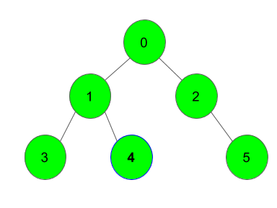
X = 4
Output:
2
Explanation:
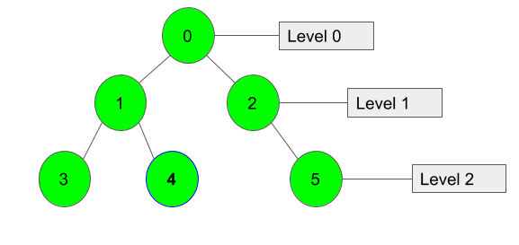
We can clearly see that Node 4 lies at Level 2.

Example 2:
Input:
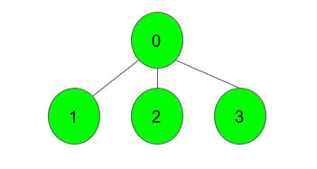
X = 1
Output:
1
Explanation:
Node 1 lies at level 1, immediate after Node 0.

Your task:
You dont need to read input or print anything. Your task is to complete the function nodeLevel() which takes two integers V and X denoting the number of vertices and the node, and another adjacency list adj as input parameters and returns the level of Node X. If node X isn't present it returns -1.
Expected Time Complexity: O(V)
Expected Auxiliary Space: O(V)
Constraints:
2 ≤ V ≤ 10⁴
1 ≤ E ≤ 10⁴
0 ≤ adj_{i, j} < V
1 ≤ X < V
Graph doesn't contain multiple edges and self loops.

Code: -
//{ Driver Code Starts
#include<bits/stdc++.h>
using namespace std;

// } Driver Code Ends

class Solution
{
public:
//Function to find the level of node X.
int nodeLevel(int V, vector<int> adj[], int X)
{
// code here
vector<bool> vis(V+1, false);
int level = 0;
queue<int> q;
q.push(0);
vis[q.front()] = true;
while(q.size()){
++level;
int count = q.size();
while(count--){
int front = q.front();
q.pop();
for(auto &i : adj[front]){
if(!vis[i]){
vis[i] = true;
if(i == X) return level;
q.push(i);
}
}
}
}
return -1;
}
};

//{ Driver Code Starts.

int main()
{

int t;
cin >> t;
while(t--)
{
int V, E, X;
cin >> V >> E;

vector<int> adj[V];

for(int i = 0; i < E; i++)
{
int u, v;
cin >> u >> v;
adj[u].push_back(v);
adj[v].push_back(u);
}
cin>>X;

Solution obj;
cout << obj.nodeLevel(V, adj, X) << "\n";
}

return 0;
}

// } Driver Code Ends

T.C: - O(V)
S.C: - O(V)

